Name: Class: Mark:

The first sound pattern below has been recorded three times using different digital sampling settings.
Recording A
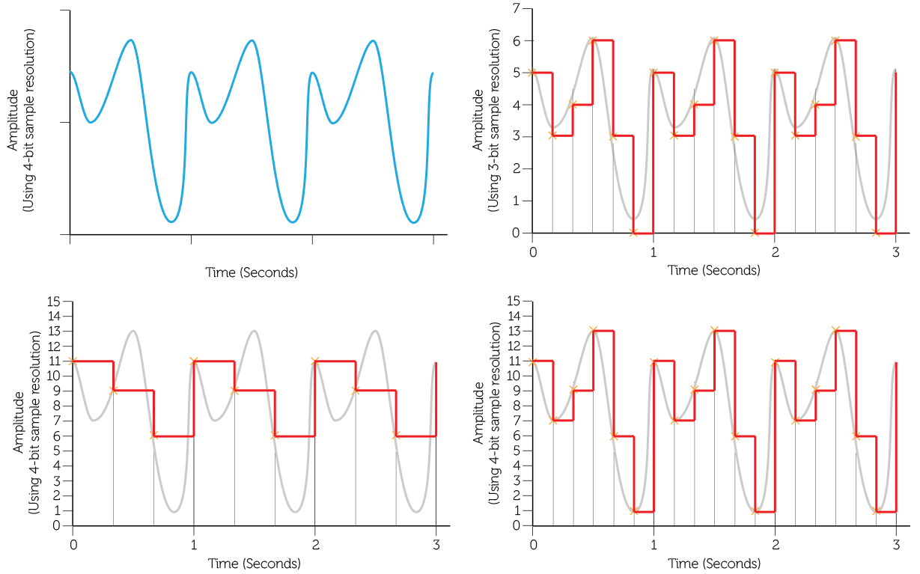
Recording C
Recording B

Calculate the file size of the each of the recordings A to C: (Show your workings) [6]

A: _____________________________________________________________________

B: _____________________________________________________________________

C: _____________________________________________________________________

Which of the recordings above will be of the highest quality? [1]

State one device that is used to capture an analogue sound signal. [1]

The length of a recording will heavily influence the size of the sound file.
State two factors other than recording length that determine the file size of a recording. [2]

A portable sound recorder is used to record an interview.
The recorder uses the following settings:

Frequency: 20 kHz

Resolution: 20 bits

Time: 1 minute 40 seconds

Calculate the file size of the interview in megabytes. [5]

[Total 15 marks]

